1. Open kompozer tool.

2. We have inserted a image into web page using insert menu.

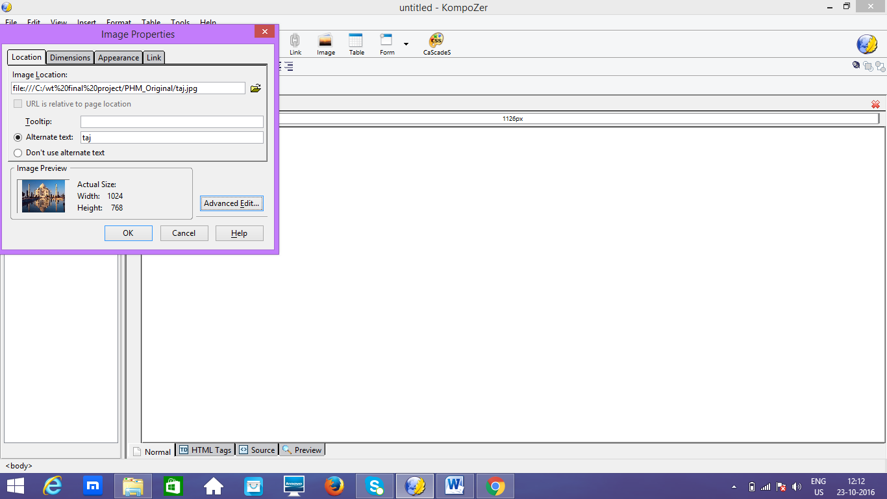

3. We have saved page designed in the file named home.html using save option.

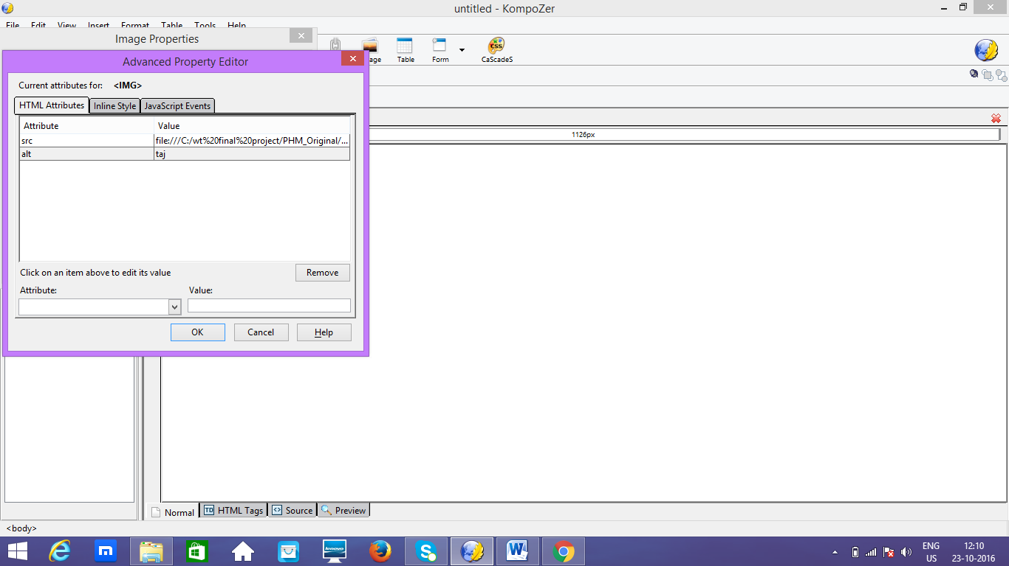

4. We can view the html code generated for this web page using view->html code option.

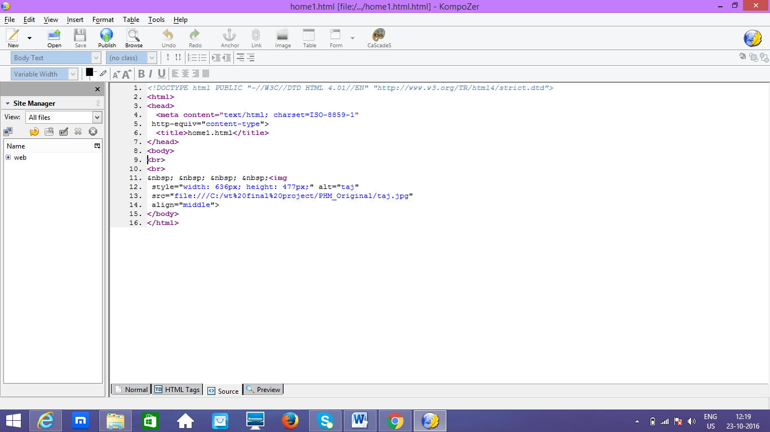

5. We can view the web page designed in browser like this.

